Outdoor Water Fountain with Cat Recognition

James Woodward-Caradonna

Date of Inception: August 7, 2026

Table of Contents

- Description of Project
- Scope of Project
- Working Ideas for Implementation
- Current Progress
  - Piece 1
  - Piece 2
  - Piece 3
  - ...
- Expected Results

Description of Project

This description will be the equivalent of a README.md file in GitHub.

The ‘Outdoor Water Fountain with Cat Recognition’ project was originally conceived because of the joy I saw from my cat Sheba when she drank from the bird bath in our backyard. Even more so than that, I would directly give her water from a small watering can, regardless of how hot it was or how much that hurt my back. Her tip-toeing up to me in the tall (to her) grass made me want to put a water fountain in our backyard for her so that she could have the running water she has always loved all while preserving my back and lack of constant availability to ‘water her’.

The primary issue with this water fountain is the fact that there are many other animals in our backyard whom I seek to avoid attracting towards the fountain. I truly want it to be strictly for Sheba, and hence, I came up with the idea to install a form of computer vision within the fountain to recognize when Sheba was in front of it. In this manner, the fountain could turn on when it saw her, and turn off otherwise. The breakdown of the solution as it stands is as follows:

This water fountain will have three primary components. The water fountain itself, the basin/container that the water will go into, and a camera attached to perhaps a raspberry pi or arduino that has a neural network loaded onto it that will sense when Sheba is nearby. In the future, I would like to also include a motion sensor (so that the fountain stops running when it detects no movement from Sheba) and perhaps a depth sensor (so it may turn on when it sees Sheba is a specified distance away). I believe the latter to be more challenging, hence I will stray away from that idea for now, but look forward to attempting to implement the former add-on.
My plan is to buy some sort of water propulsion device, similar to a water gun, that turns on when it detects Sheba’s presence. In the ideal, this device will have two outlets that Sheba may drink from. I would like the water propulsion device to propel water at a very low pressure to allow for Sheba to essentially drink from the spout. Then, any water that is not drunk by Sheba would go down a spout and into a basin/container at ground level that Sheba can drink directly out of. I want this container to act like a sink. When it gets too full, it will drain into a basin that collects the water, which will then be sent back out by the propulsion device. In the event Sheba wants to drink from the lower basin, she may, and when she leaves, I hope for the container to drain, and to send that extra water back into a tank for the device to retrieve water from later. I attach below a couple of rough sketches of what I hope for this to ultimately look like.

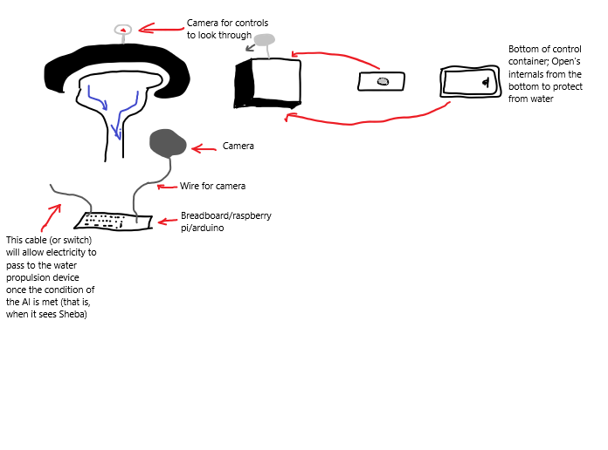
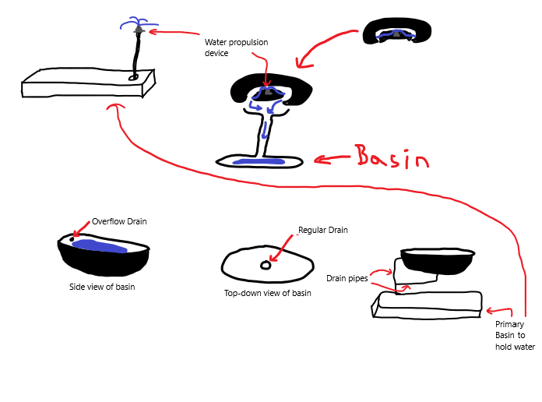

Scope of Project

The scope of this project is important to define. I have lots of parts that I would like to implement, but I am not sure how much of it I will actually be able to do. At the very least, I would like to develop an AI that can recognize Sheba but will also be able to detect other animals such as a chipmunk, raccoon, or otherwise. This idea will be by no means perfect, and I do not expect such. At least, not for this project.

In the ideal, I would like to develop the AI, transfer it to an arduino/breadboard/raspberry pi, connect it to a camera, and try to access the camera myself. That is, be able to see the AI properly detecting Sheba. I would then like to also develop the rest of the structure, but I may need some additional help doing so as parts of it may be too difficult for me to learn (such as the CAD software etc., though I would like to learn that). The first iteration of this project will not be what I ultimately would like for this project to be, and that is okay. I would like this project to be a pilot project towards a more developed idea that I can refine later.

As such, the scope of this project will be limited to making everything in a way that produces a “proof-of-concept” result. That is to say that the device itself I do not expect to be perfect, but I am looking for it to prove that the idea is viable. This means I would like to be able to make the AI, transfer it to a board as mentioned above, connect it to the water propulsion device, connect that device to a battery or to the wall, whichever it specifies it needs, then hook up all of that to a fountain. I do not expect the fountain to be perfect, I expect mistakes. As well, I expect even the contraption to not be ideal for harsher weather (heavy rainfall, snow, ice, etc.). All of the more nitty gritty stuff I can worry about at a later date.

Working Ideas for Implementation

